17.74: From Eq. (17.25), with 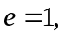
a)
b) A factor of ten increase in temperature results in a factor of 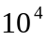 increase in the output; 